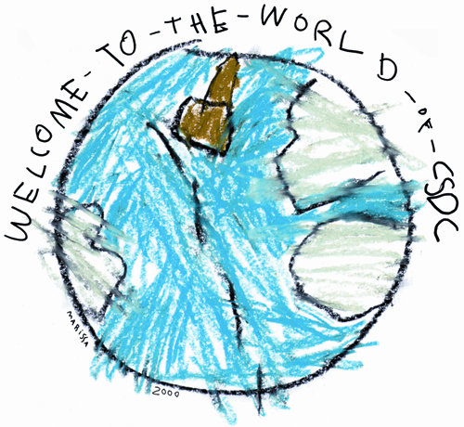**UNH Child Study and Development Center**

**Part time Calendar**

2023-2024 Academic Year

**Fall Semester 2023** – *UNH classes start on Monday, August 28th*

Mon. Aug. 21st MAP Orientation for Families

(Schedule will be sent from classroom teachers mid-August)

Tues. Aug. 22nd MAP 2 & 3 Staggered Enrollment

(Schedule will be sent from classroom teachers mid-August)

Mon. Sept. 4th Center Closed: University Holiday

Mon. Oct. 9th Center Closed: No UNH Classes; Teacher Professional Development Day

Fri. Nov. 10th Center Closed: University Holiday

Wed. - Fri. Nov. 22nd, 23rd & 24th Center Closed: University Holidays

Thurs. Dec. 7th Last day for MAP 2 until January 2nd

Fri. Dec 8th Last day for MAP 3 until January 3rd

Mon. Dec. 11th – Fri. Dec. 15th MAP Conferences (Sign-up sheet will be used)

Mon. Dec. 18th – Fri., Dec. 29th Center Closed: Winter Shutdown

**Spring Semester 2024 –** *UNH classes start on Tuesday, January 23rd & end on Monday, May 6th*

Mon. Jan. 1st Center Closed: University Holiday

Tues. Jan. 2nd  MAP 2 reopens at 9:00am & J-Term Begins

Weds. Jan. 3rd MAP 3 reopens at 9:00am

Mon. Jan. 15th Center Closed: University Holiday

Tues. Jan. 23rd Spring semester classes begin

Mon. Mar. 18th – Fri. Mar. 22nd **No MAP in session (Spring Break)**

Mon. May 6th Last day of UNH classes

Mon. May 27th Center Closed: University Holiday

Thurs. May 30th  Last Day of MAP 2

Fri. May 31st  Last Day of MAP 3

Mon. June 3rd – Wed. June12th MAP Conferences (Sign-up sheet will be used)